# Device Variants

This device has three options for mounting plate width and three options for tee nut length. To find accurate print details for each variant, find the corresponding table for your configuration.

# 3D Printing Summary

|  |  |  |  |  |
| --- | --- | --- | --- | --- |
| **Configuration** | **Total Print Time (min)** | **Total Number of Components** | **Typical Total Mass (g)** | **Typical Number of Print Setups** |
| **Configuration 1**  Small Plate with 5/16” Tee Nut | 84 | 3 | 11 | 1 |
| **Configuration 2**  Small Plate with 7/16” Tee Nut | 88 | 3 | 12 | 1 |
| **Configuration 3**  Small Plate with 9/16” Tee Nut | 94 | 3 | 13 | 1 |
| **Configuration 4**  Medium Plate with 5/16” Tee Nut | 149 | 3 | 19 | 1 |
| **Configuration 5**  Medium Plate with 7/16” Tee Nut | 143 | 3 | 21 | 1 |
| **Configuration 6**  Medium Plate with 9/16” Tee Nut | 152 | 3 | 23 | 1 |
| **Configuration 7**  Large Plate with 5/16” Tee Nut | 214 | 3 | 29 | 1 |
| **Configuration 8**  Large Plate with 7/16” Tee Nut | 232 | 3 | 32 | 1 |
| **Configuration 9**  Large Plate with 9/16” Tee Nut | 252 | 3 | 35 | 1 |

# 3D Printing Settings

## Configuration 1: Small Plate with 5/16” Tee Nut

|  |  |  |  |  |  |  |  |
| --- | --- | --- | --- | --- | --- | --- | --- |
| **Print File Name** | **Qty** | **Total Print Time (hr:min)** | **Mass**  **(g)** | **Infill**  **(%)** | **Support**  **(Y/N)** | **Layer Height/ Nozzle Diameter(mm)** | **Notes (orientation, special settings, etc.)** |
| 45_Mounting_Plate_5.stl | 1 | 1:09 | 9 | 20 | N | 0.2/0.4 | Print in orientation given in STL |
| Hardware_Cover.stl | 1 | 00:10 | 1 | 20 | N | 0.2/0.4 | Print in orientation given in STL |
| Assembly_Washer.stl  (Optional) | 1 | 00:05 | 1 | 20 | N | 0.2/0.4 | Print in orientation given in STL |

## Configuration 2: Small Plate with 7/16” Tee Nut

|  |  |  |  |  |  |  |  |
| --- | --- | --- | --- | --- | --- | --- | --- |
| **Print File Name** | **Qty** | **Total Print Time (hr:min)** | **Mass**  **(g)** | **Infill**  **(%)** | **Support**  **(Y/N)** | **Layer Height/ Nozzle Diameter(mm)** | **Notes (orientation, special settings, etc.)** |
| 45_Mounting_Plate_7.stl | 1 | 1:13 | 10 | 20 | N | 0.2/0.4 | Print in orientation given in STL |
| Hardware_Cover.stl | 1 | 00:10 | 1 | 20 | N | 0.2/0.4 | Print in orientation given in STL |
| Assembly_Washer.stl  (Optional) | 1 | 00:05 | 1 | 20 | N | 0.2/0.4 | Print in orientation given in STL |

## Configuration 3: Small Plate with 9/16” Tee Nut

|  |  |  |  |  |  |  |  |
| --- | --- | --- | --- | --- | --- | --- | --- |
| **Print File Name** | **Qty** | **Total Print Time (hr:min)** | **Mass**  **(g)** | **Infill**  **(%)** | **Support**  **(Y/N)** | **Layer Height/ Nozzle Diameter(mm)** | **Notes (orientation, special settings, etc.)** |
| 45_Mounting_Plate_9.stl | 1 | 1:19 | 11 | 20 | N | 0.2/0.4 | Print in orientation given in STL |
| Hardware_Cover.stl | 1 | 00:10 | 1 | 20 | N | 0.2/0.4 | Print in orientation given in STL |
| Assembly_Washer.stl  (Optional) | 1 | 00:05 | 1 | 20 | N | 0.2/0.4 | Print in orientation given in STL |

## Configuration 4: Medium Plate with 5/16” Tee Nut

|  |  |  |  |  |  |  |  |
| --- | --- | --- | --- | --- | --- | --- | --- |
| **Print File Name** | **Qty** | **Total Print Time (hr:min)** | **Mass**  **(g)** | **Infill**  **(%)** | **Support**  **(Y/N)** | **Layer Height/ Nozzle Diameter(mm)** | **Notes (orientation, special settings, etc.)** |
| 65_Mounting_Plate_5.stl | 1 | 2:14 | 17 | 20 | N | 0.2/0.4 | Print in orientation given in STL |
| Hardware_Cover.stl | 1 | 00:10 | 1 | 20 | N | 0.2/0.4 | Print in orientation given in STL |
| Assembly_Washer.stl  (Optional) | 1 | 00:05 | 1 | 20 | N | 0.2/0.4 | Print in orientation given in STL |

## Configuration 5: Medium Plate with 7/16” Tee Nut

|  |  |  |  |  |  |  |  |
| --- | --- | --- | --- | --- | --- | --- | --- |
| **Print File Name** | **Qty** | **Total Print Time (hr:min)** | **Mass**  **(g)** | **Infill**  **(%)** | **Support**  **(Y/N)** | **Layer Height/ Nozzle Diameter(mm)** | **Notes (orientation, special settings, etc.)** |
| 65_Mounting_Plate_7.stl | 1 | 2:08 | 19 | 20 | N | 0.2/0.4 | Print in orientation given in STL |
| Hardware_Cover.stl | 1 | 00:10 | 1 | 20 | N | 0.2/0.4 | Print in orientation given in STL |
| Assembly_Washer.stl  (Optional) | 1 | 00:05 | 1 | 20 | N | 0.2/0.4 | Print in orientation given in STL |

## Configuration 6: Medium Plate with 9/16” Tee Nut

|  |  |  |  |  |  |  |  |
| --- | --- | --- | --- | --- | --- | --- | --- |
| **Print File Name** | **Qty** | **Total Print Time (hr:min)** | **Mass**  **(g)** | **Infill**  **(%)** | **Support**  **(Y/N)** | **Layer Height/ Nozzle Diameter(mm)** | **Notes (orientation, special settings, etc.)** |
| 65_Mounting_Plate_9.stl | 1 | 2:17 | 21 | 20 | N | 0.2/0.4 | Print in orientation given in STL |
| Hardware_Cover.stl | 1 | 00:10 | 1 | 20 | N | 0.2/0.4 | Print in orientation given in STL |
| Assembly_Washer.stl  (Optional) | 1 | 00:05 | 1 | 20 | N | 0.2/0.4 | Print in orientation given in STL |

## Configuration 7: Large Plate with 5/16” Tee Nut

|  |  |  |  |  |  |  |  |
| --- | --- | --- | --- | --- | --- | --- | --- |
| **Print File Name** | **Qty** | **Total Print Time (hr:min)** | **Mass**  **(g)** | **Infill**  **(%)** | **Support**  **(Y/N)** | **Layer Height/ Nozzle Diameter(mm)** | **Notes (orientation, special settings, etc.)** |
| 85_Mounting_Plate_5.stl | 1 | 3:19 | 27 | 20 | N | 0.2/0.4 | Print in orientation given in STL |
| Hardware_Cover.stl | 1 | 00:10 | 1 | 20 | N | 0.2/0.4 | Print in orientation given in STL |
| Assembly_Washer.stl  (Optional) | 1 | 00:05 | 1 | 20 | N | 0.2/0.4 | Print in orientation given in STL |

## Configuration 8: Large Plate with 7/16” Tee Nut

|  |  |  |  |  |  |  |  |
| --- | --- | --- | --- | --- | --- | --- | --- |
| **Print File Name** | **Qty** | **Total Print Time (hr:min)** | **Mass**  **(g)** | **Infill**  **(%)** | **Support**  **(Y/N)** | **Layer Height/ Nozzle Diameter(mm)** | **Notes (orientation, special settings, etc.)** |
| 85_Mounting_Plate_7.stl | 1 | 3:37 | 30 | 20 | N | 0.2/0.4 | Print in orientation given in STL |
| Hardware_Cover.stl | 1 | 00:10 | 1 | 20 | N | 0.2/0.4 | Print in orientation given in STL |
| Assembly_Washer.stl  (Optional) | 1 | 00:05 | 1 | 20 | N | 0.2/0.4 | Print in orientation given in STL |

## Configuration 9: Large Plate with 9/16” Tee Nut

|  |  |  |  |  |  |  |  |
| --- | --- | --- | --- | --- | --- | --- | --- |
| **Print File Name** | **Qty** | **Total Print Time (hr:min)** | **Mass**  **(g)** | **Infill**  **(%)** | **Support**  **(Y/N)** | **Layer Height/ Nozzle Diameter(mm)** | **Notes (orientation, special settings, etc.)** |
| 85_Mounting_Plate_9.stl | 1 | 3:57 | 33 | 20 | N | 0.2/0.4 | Print in orientation given in STL |
| Hardware_Cover.stl | 1 | 00:10 | 1 | 20 | N | 0.2/0.4 | Print in orientation given in STL |
| Assembly_Washer.stl  (Optional) | 1 | 00:05 | 1 | 20 | N | 0.2/0.4 | Print in orientation given in STL |

# Post-Processing

The mounting plate has a sacrificial bridge across tee nut mount that must be removed. Use pliers to clear this and any other loose print material. All parts should be inspected to ensure that all surfaces are smooth, and edges are non-sharp.

## **Customization Options**

Users may request their choice print colour and mounting plate size from small, medium, and large. There are also three variants of tee nut sizes to match the hardware the builder chooses to use. Use the Sizing Diagram to verify what size tee nut you are using and select the corresponding STL file for the mounting plate.

## **Custom Hardware**

Print files have been released for 3 mounting plate sizes with 3 tee nut sizes each, but custom hardware and sizes can also be implemented. A parametric Fusion 360 model is available that can be adjusted to make custom mounting plates.

|  |
| --- |
|  |

# Examples of Quality Prints

## Photos of the Mounting Plate

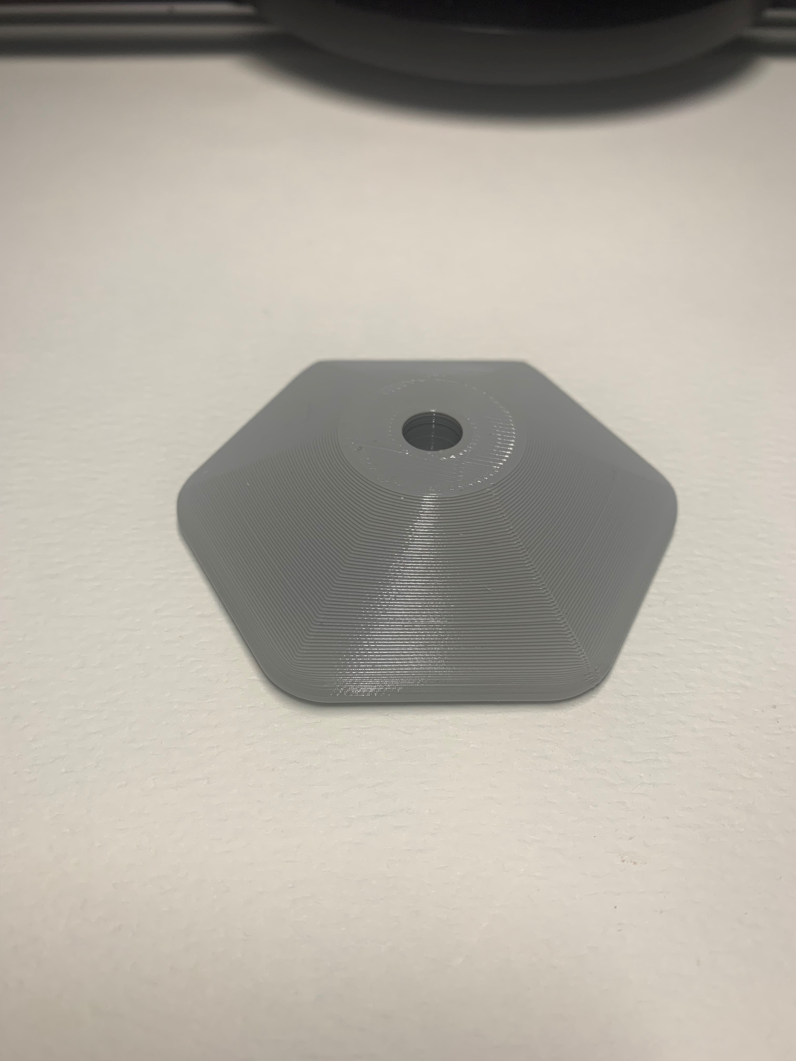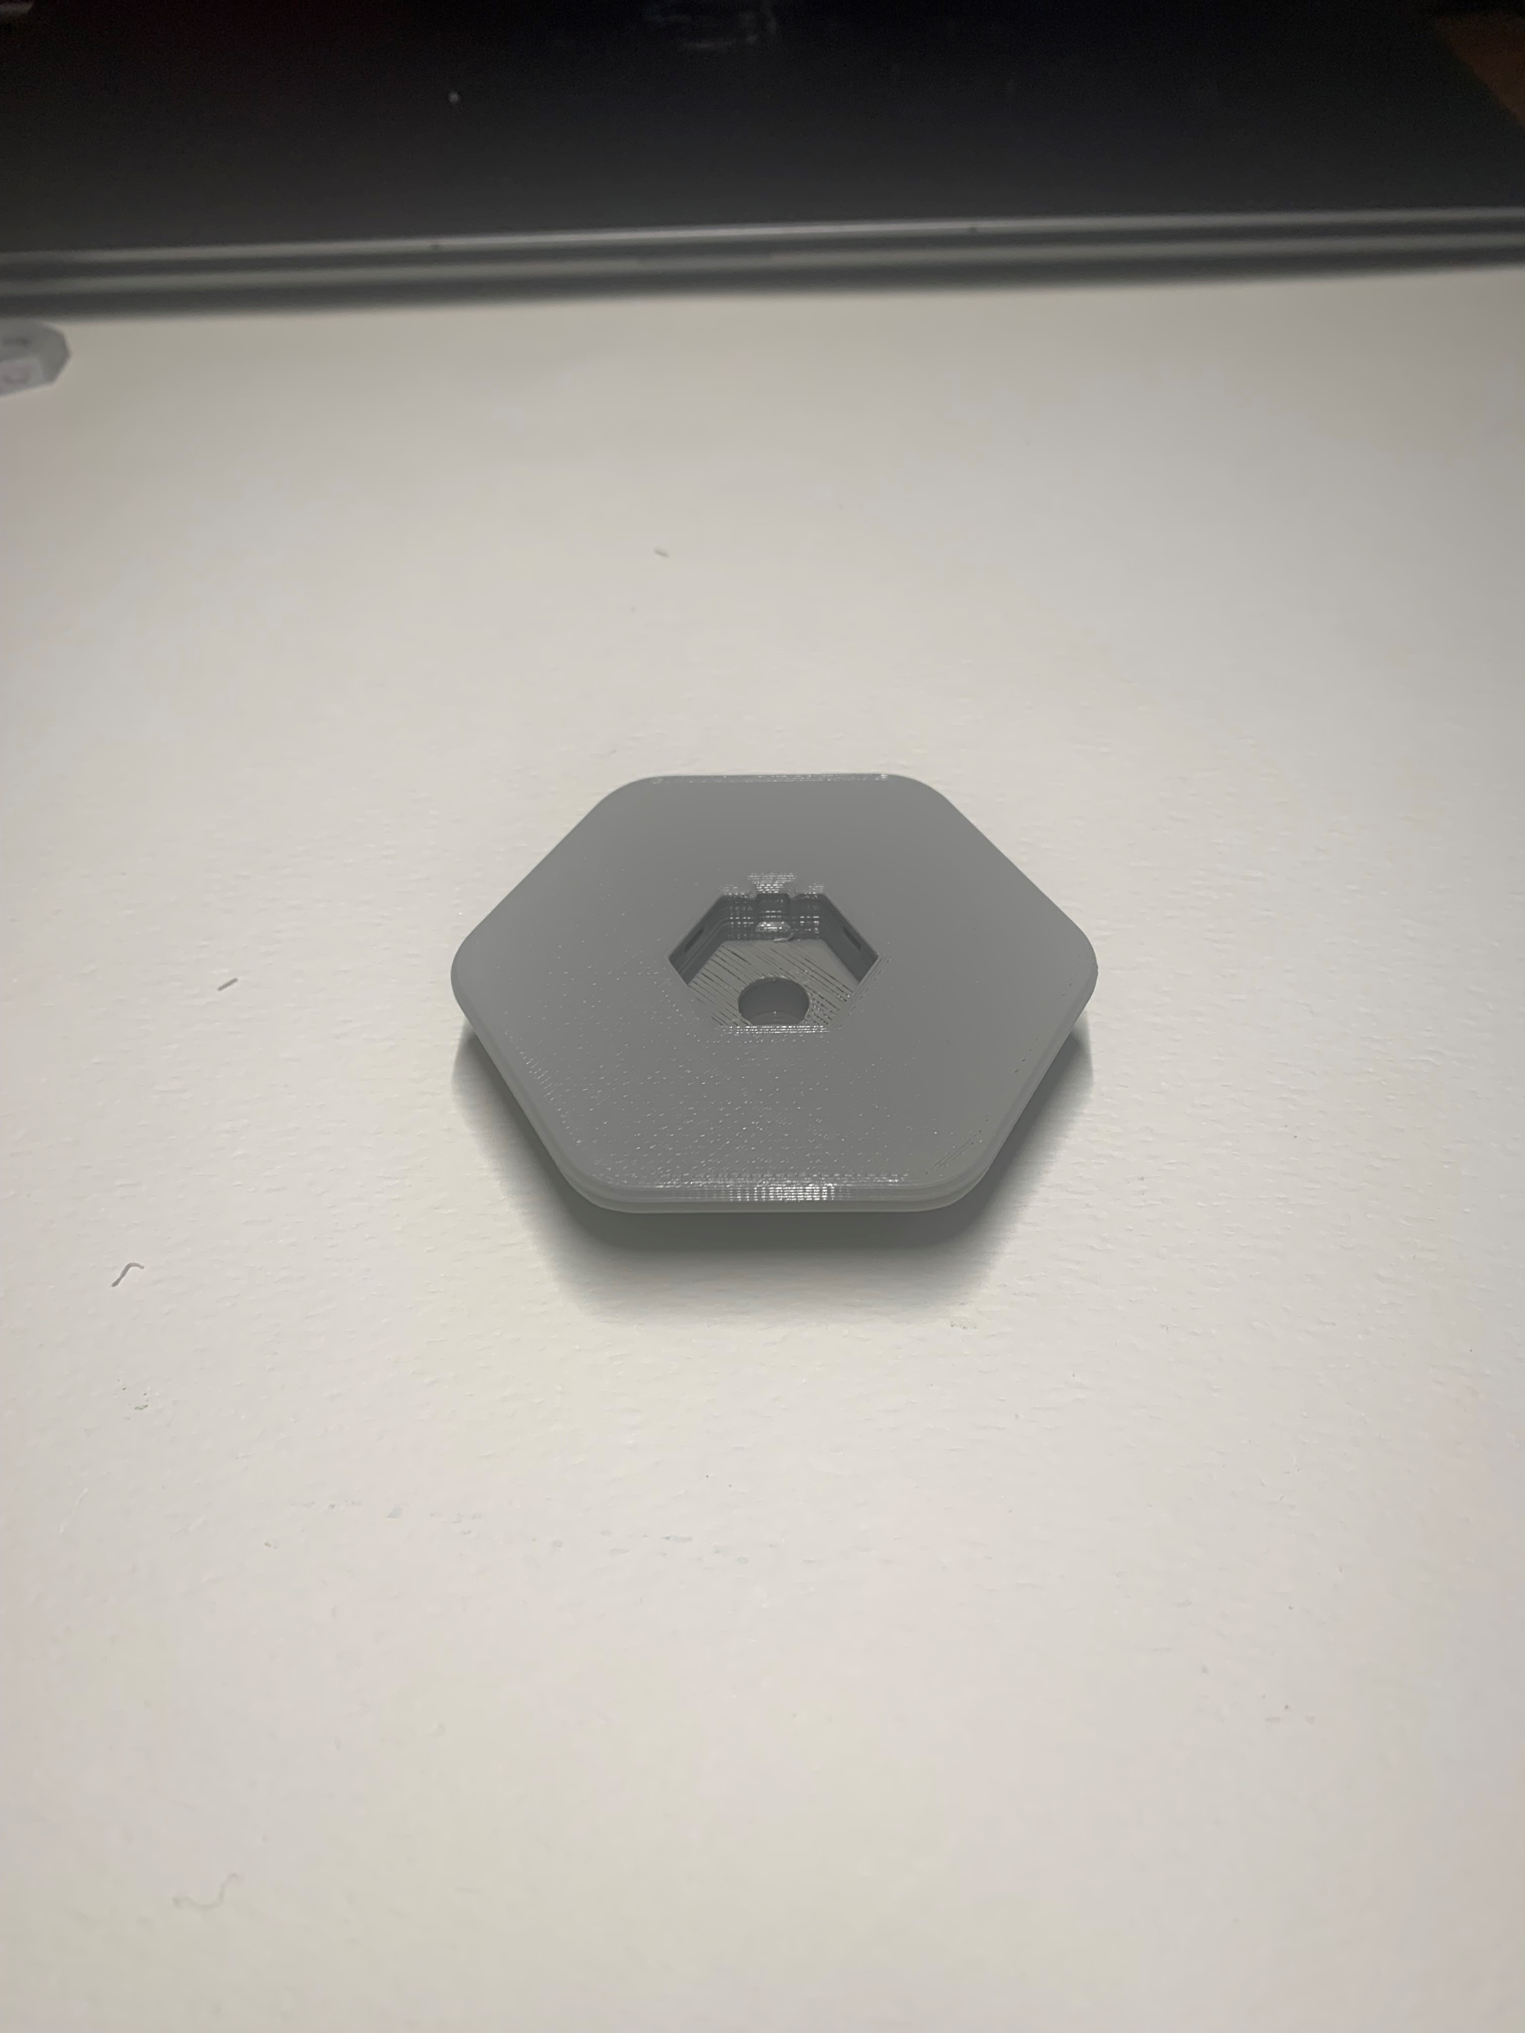

**Note:** This is an example of one of the nine total options of the mounting plate.

## Photos of the Hardware Cover

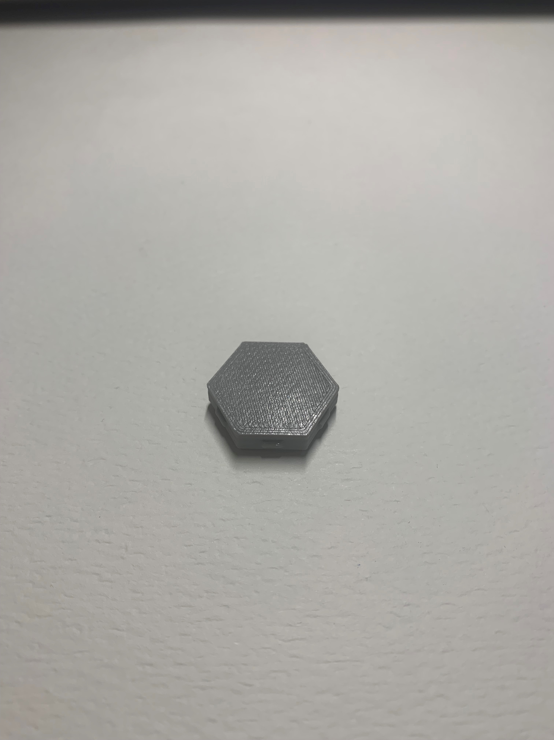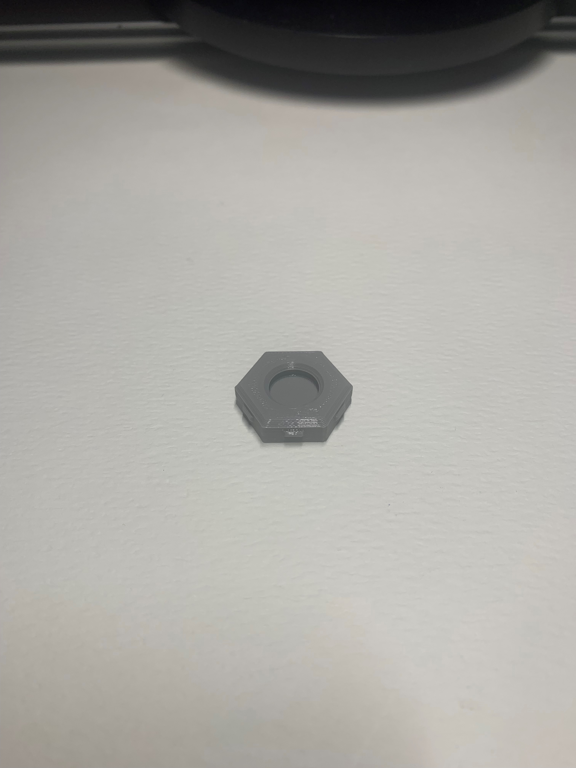

## Photos of the Assembly Washer

